Lab 1 Notes

Program memory is 2 byte (1 word)

Z = r30, r31? 31 is the higher byte?

Y= r28, r29? 29 is the higher byte

X = r26, r27

More than 16 bits. Use RAMP. Use it to address data with more than 16 bits.

Z points to program memory

X, Y, Z points to data memory

lpm = assume lpm r0, Z

ELPM- trying to load from address

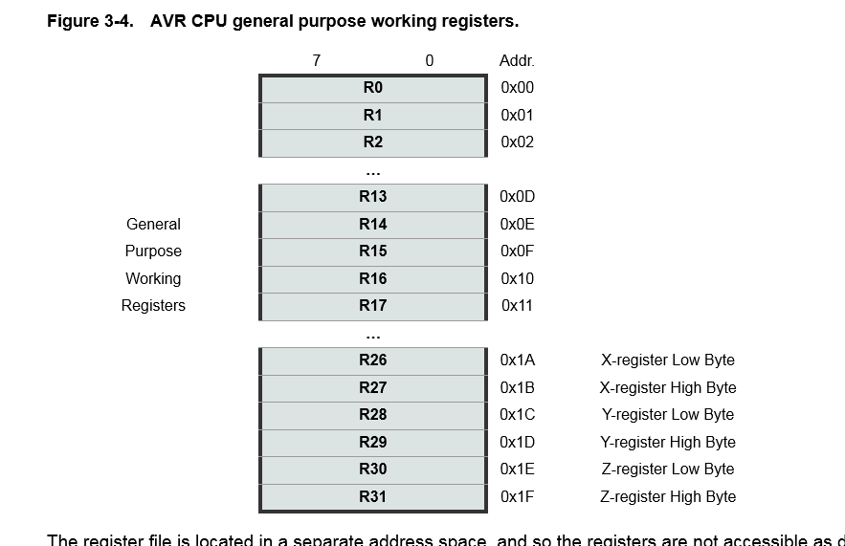

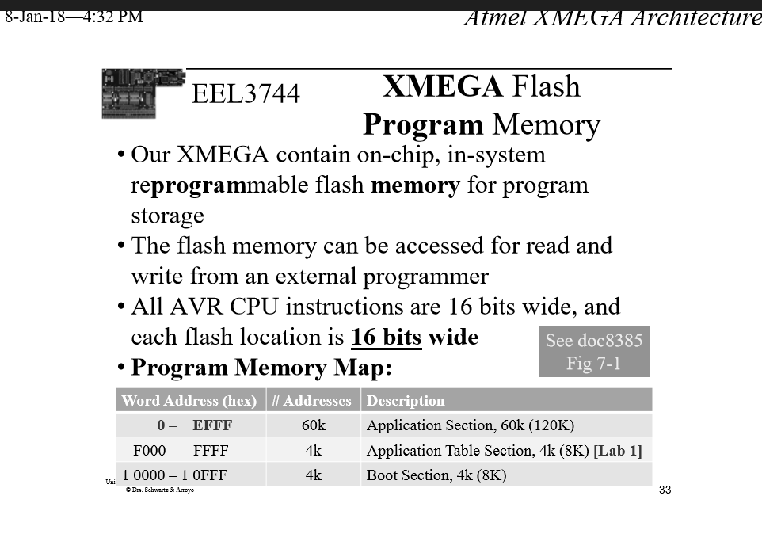

The range of program memory we can use? Or data

$2000- $3FFF

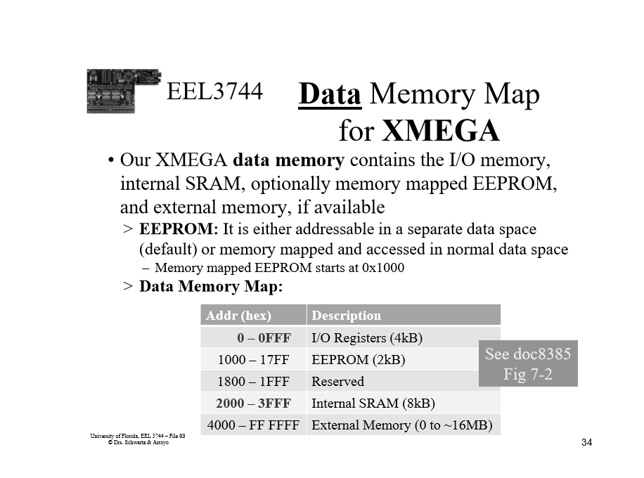

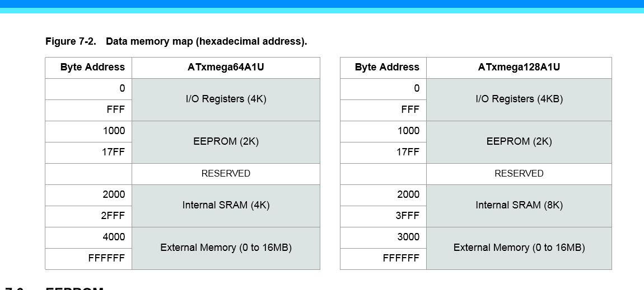

1Kb= 1024 bytes